(Developer) How to customize the IRPS Docker Image

1- Change some config in the following files:

A- env-example

I- Replace INSTALL_APPS=erpnext,metabase_integration,[your custom app]...

ii- Replace DOCKER_USERNAME with the docker username of the owner that has the images of custom-erpnext-nginx and custom-erpnext-worker

B- nginx/Dockerfile

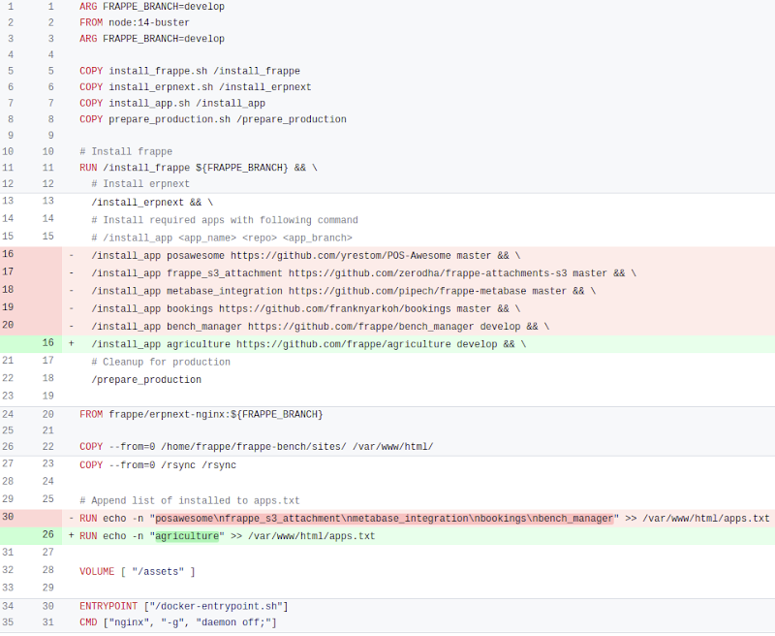

C- worker/Dockerfile

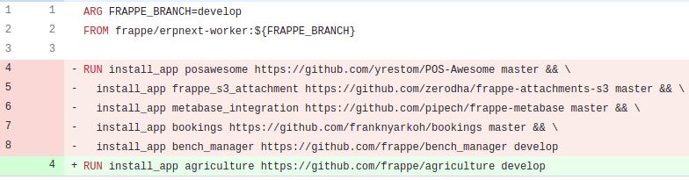

2- Remember to copy env-example into .env (cp env-example .env)

a- Build your docker images

1. nginx

docker build --build-arg=FRAPPE_BRANCH=version-12 -t custom-erpnext-nginx:v12 nginx

1. iworker

docker build --build-arg=FRAPPE_BRANCH=version-12 -t custom-erpnext-worker:v12 worker

Note: Change The docker images as your image in my case I just added -1 to become

custom-erpnext-worker-1

note:- you can check you docker images by run this command (docker images)

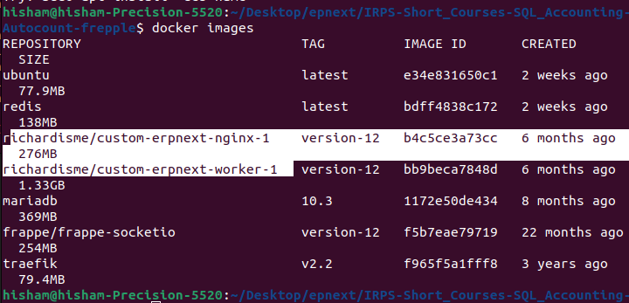

3- Push your docker images to Docker Hub, refer [this](https://www.google.com/url?q=https://www.google.com/url?q%3Dhttps://docs.docker.com/get-started/04_sharing_app/%26amp;sa%3DD%26amp;source%3Deditors%26amp;ust%3D1694750184032856%26amp;usg%3DAOvVaw2bteJG-DFhMVsbOPRuAepZ&sa=D&source=docs&ust=1694750184042383&usg=AOvVaw0xiLTFpFmGgiUFI3Ndn-w6).

**Note:** Best to set the image tag name to be the same as frappe/erpnext branch (e.g. version-12)

4- Push your docker images to Docker Hub, refer [this](https://www.google.com/url?q=https://www.google.com/url?q%3Dhttps://docs.docker.com/get-started/04_sharing_app/%26amp;sa%3DD%26amp;source%3Deditors%26amp;ust%3D1694750184032856%26amp;usg%3DAOvVaw2bteJG-DFhMVsbOPRuAepZ&sa=D&source=docs&ust=1694750184042383&usg=AOvVaw0xiLTFpFmGgiUFI3Ndn-w6).

**Note:** Best to set the image tag name to be the same as frappe/erpnext branch (e.g. version-12)

1. log in in Docker Hub
2. Select the Create Repository button.
3. For the repository name, use getting-started. Make sure the Visibility is Public.  
   In my case I named my repository as custom-erpnext-nginx
4. Select Create.

- In the following image, you can see an example Docker command from Docker Hub. This command will push to this repository.  
 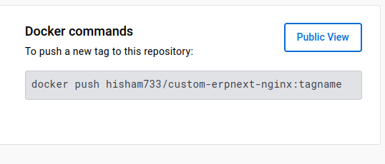

1. Sign in to Docker Hub using the command docker login -u YOUR-USER-NAME
2. Use the docker tag command to give the getting-started image a new name. Replace YOUR-USER-NAME with your Docker ID.

docker tag erpnext image YOUR-USER-NAME/docker hub image

For Example

docker tag custom-erpnext-nginx-2:v12 hisham733/custom-erpnext-nginx:version-12

1. Now run the docker push command

docker push YOUR-USER-NAME/getting-started  
  
for example   
 docker push hisham733/custom-erpnext-nginx:version-12

1. repeat all the steps to push the worker file

create new repository for example

for example

docker push hisham733/custom-erpnext-worker:tagname

1. Use the docker tag command

for example

docker tag custom-erpnext-worker-2:v12 hisham733/custom-erpnext-worker:version-12

1. Now run the docker push command

docker push YOUR-USER-NAME/getting-started  
  
for example   
 docker push hisham733/custom-erpnext-worker:version-12

In the following image you can check your Docker Hub to see the pushing images   
  
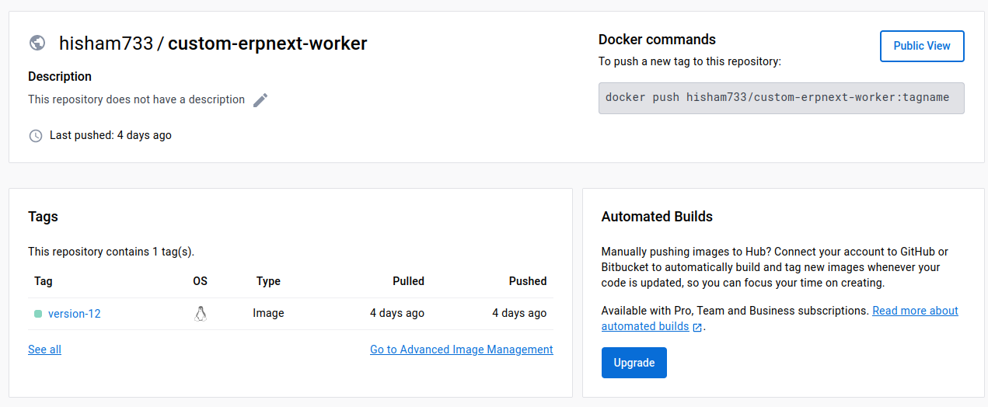

If everything is working as intended, push the whole shrdc_custom_frappe_docker to a Github repo. As long as user has Docker Desktop (Windows), or Docker Engine & Docker Compose (Ubuntu), they can use this app with 3 steps: git clone, copy environment variables into .env, docker-compose up

To push the ERPnext that including the new app in GitHub

1. Go to your profile in GitHub
2. Ceate a new repository and name it

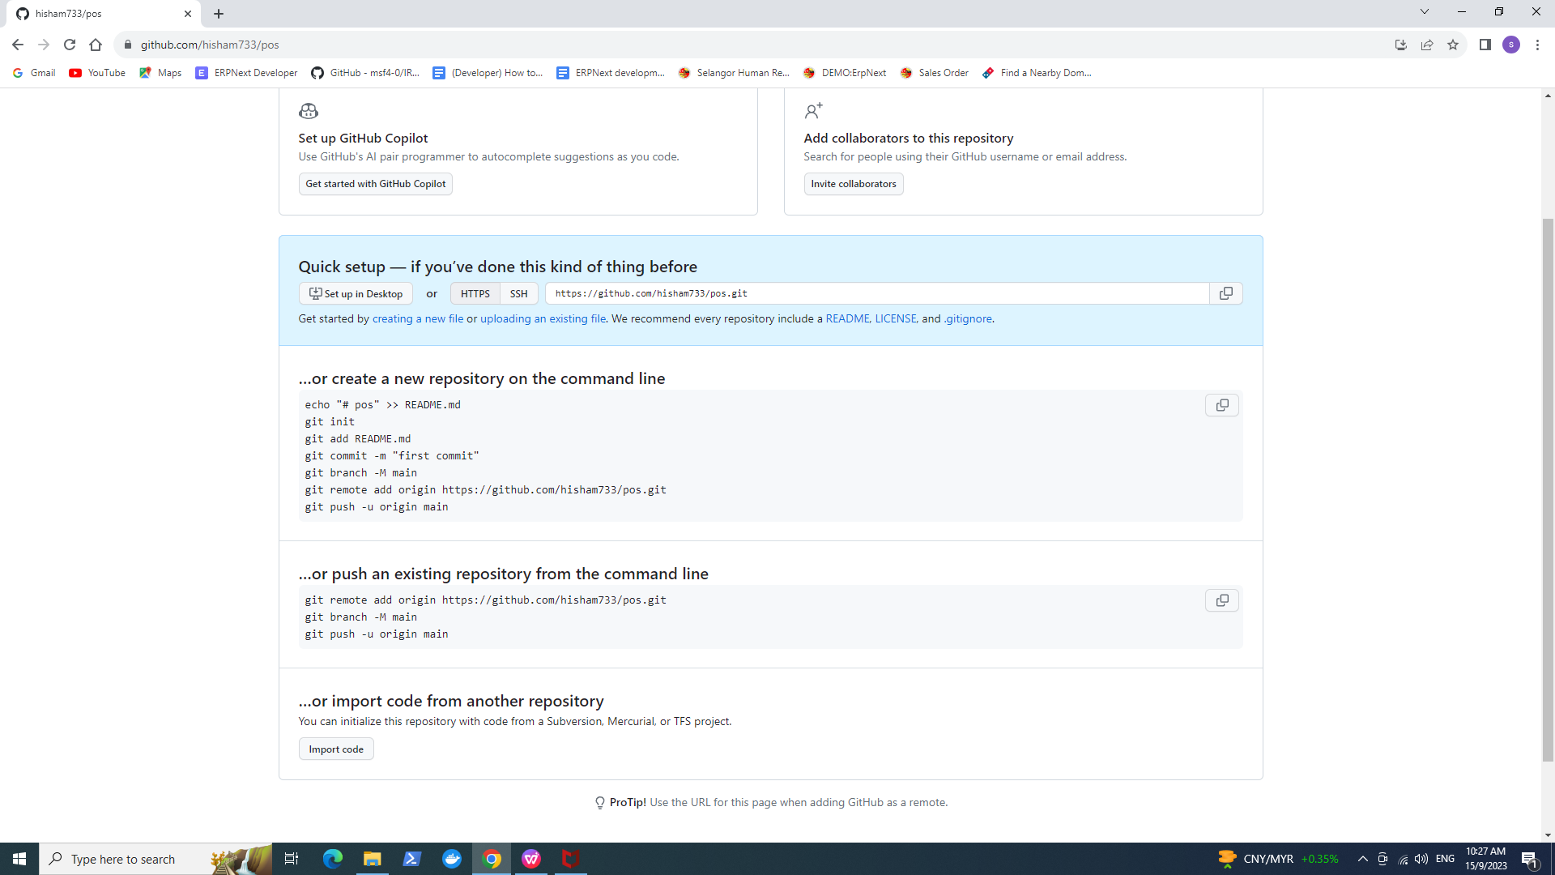

1. navigate to ERPnext file

For Example

C:\Desktop\short_production\IRPS-Short_Courses-SQL_Accounting-Autocount-frepple

1. Run the repo commands

git init

git commit -m "first commit"

git branch -M main

git remote add origin https://github.com/hisham733/pos.git

git push -u origin main

Note: do not run the git add README.md command u will edit that file latter

If you faced error: remote origin already exists just change it to any name  
  
5- check the READE.md file in your repo if neads any editing   
6- check the env_example file in your repo and check your new app should be there as will as your user name

now you can clone the new repository that contain the ERPnext including the new app